**Azure Databricks workspace setup and cluster creation**

**Name: PRIYESHWAR**

**Mail:** [**priyesh2664@gmail.com**](mailto:priyesh2664@gmail.com)

Go to the Azure Dashboard

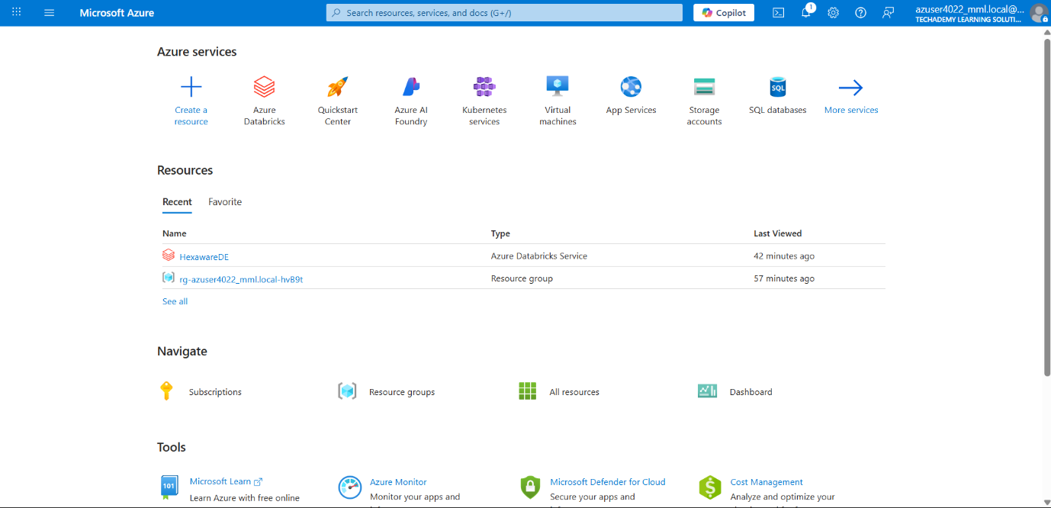

In the search bar, search Azure Databricks

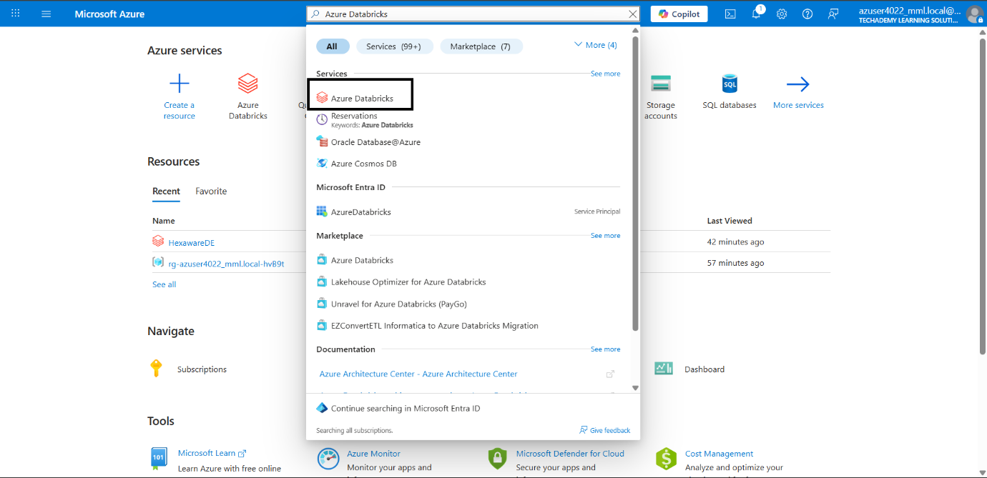

In the Azure Databricks page, click the Create option

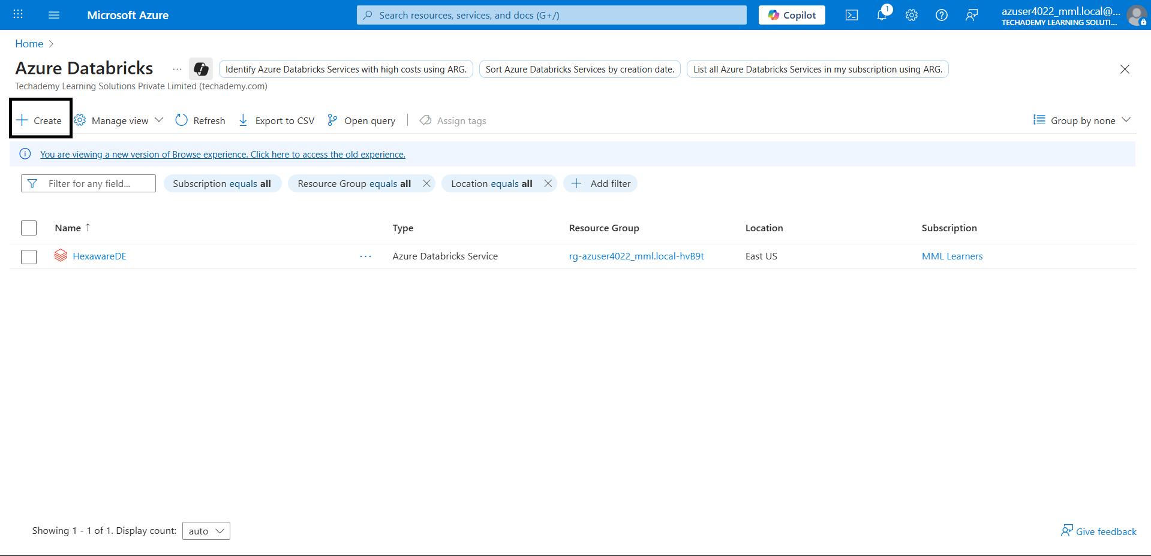

In basic, set the configurations like workspace name, pricing tier, etc.

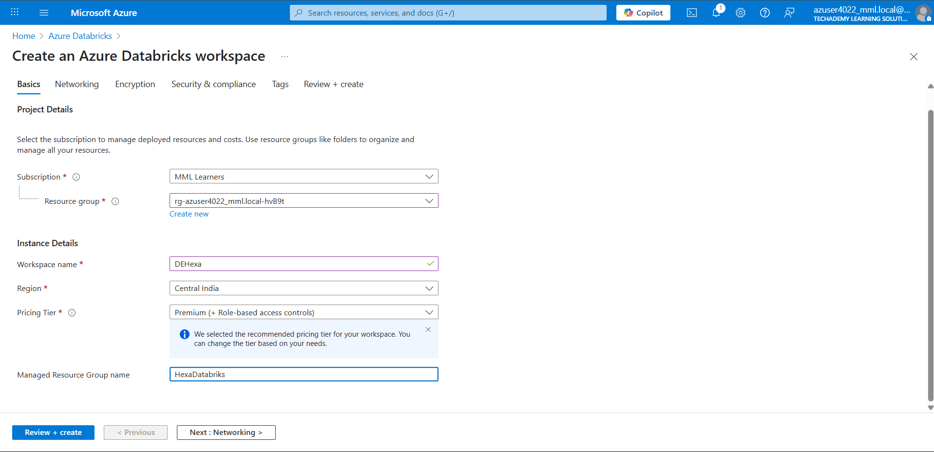

In Networking, set the network configurations

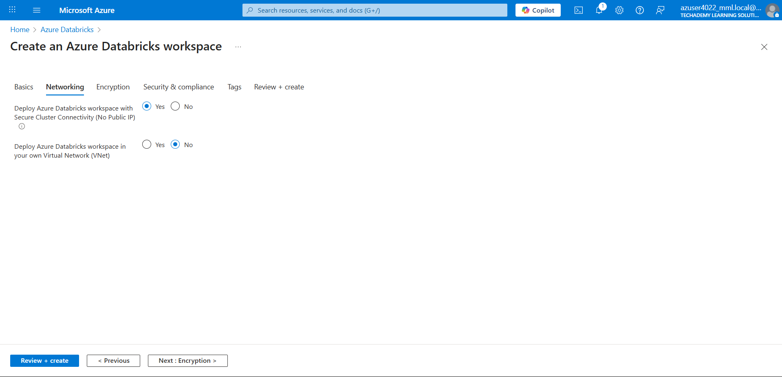

In Encryption, set the encryption if needed

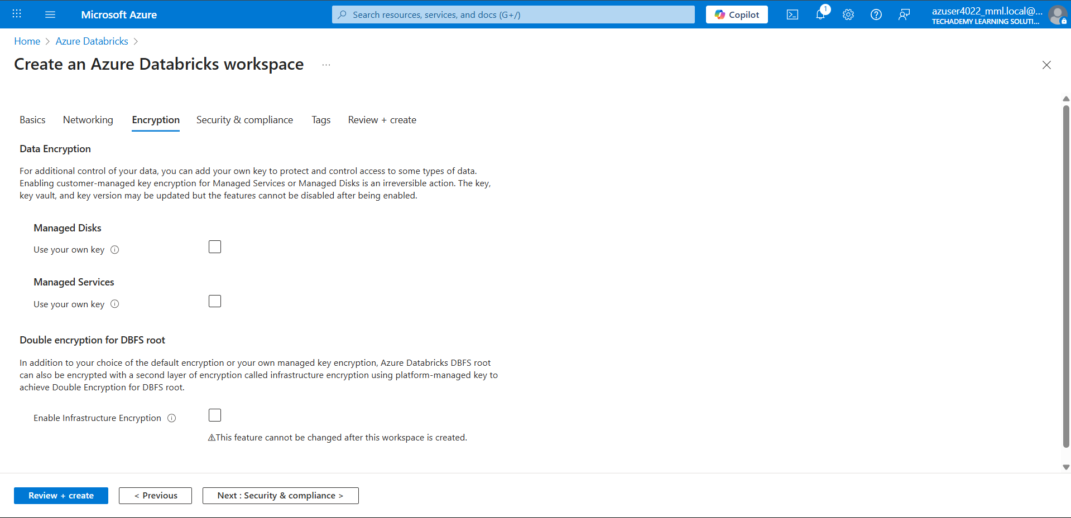

Set the security if needed, and click review and create

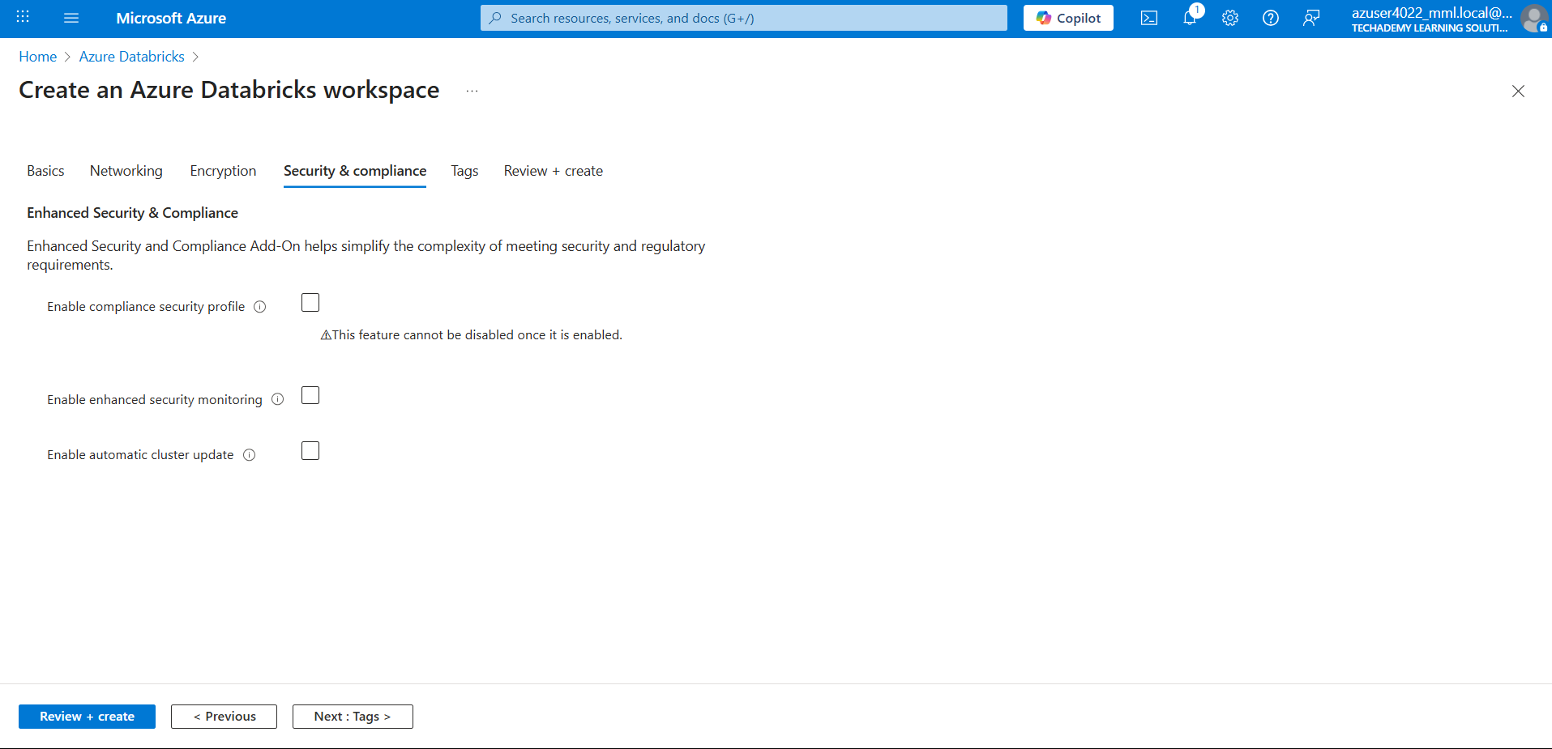

Once validation succeeded, click create

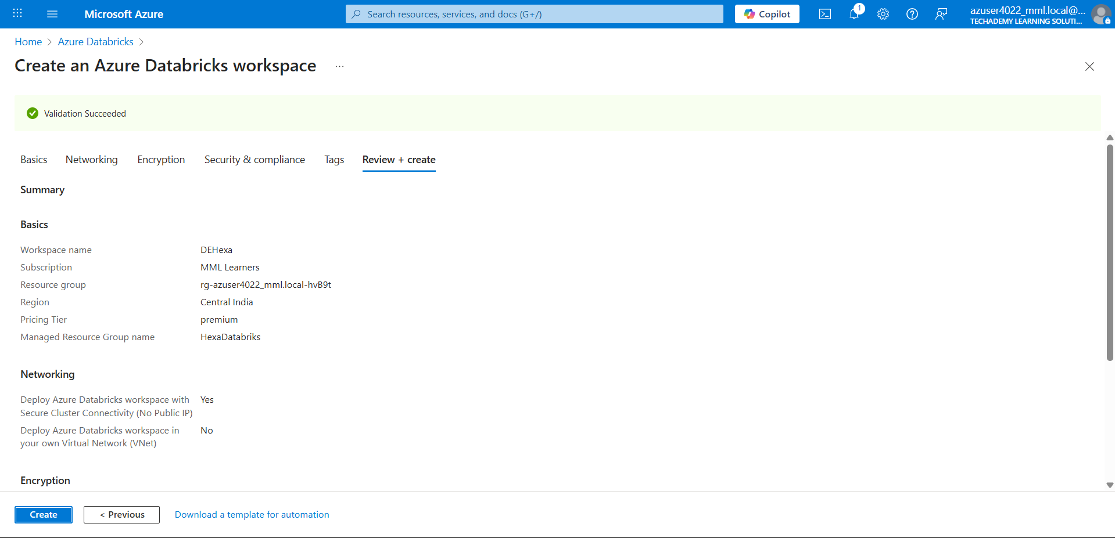

Once the workspace is created successfully, launch the workspace.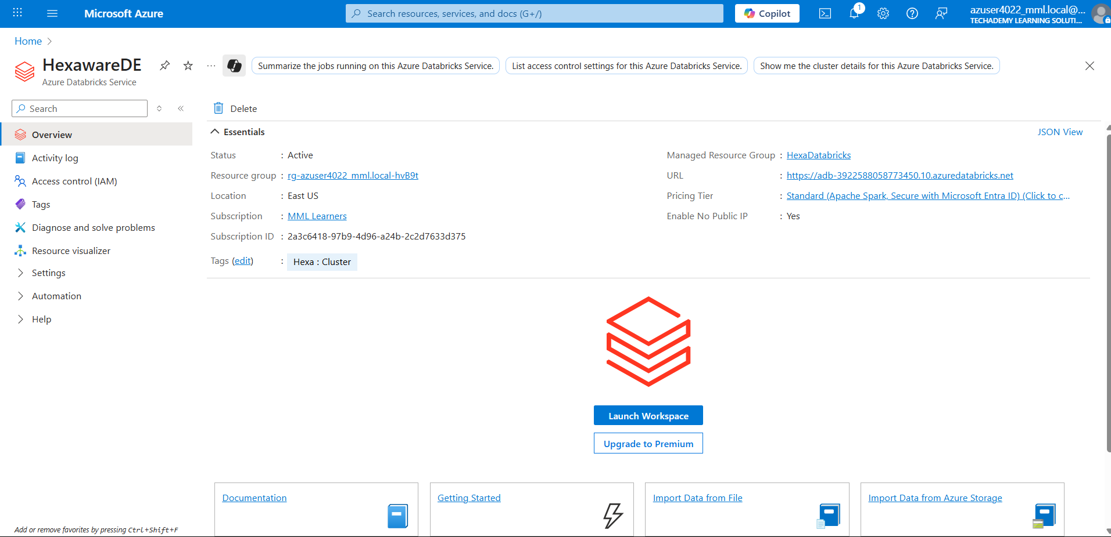

In the Databricks dashboard, goto Compute   
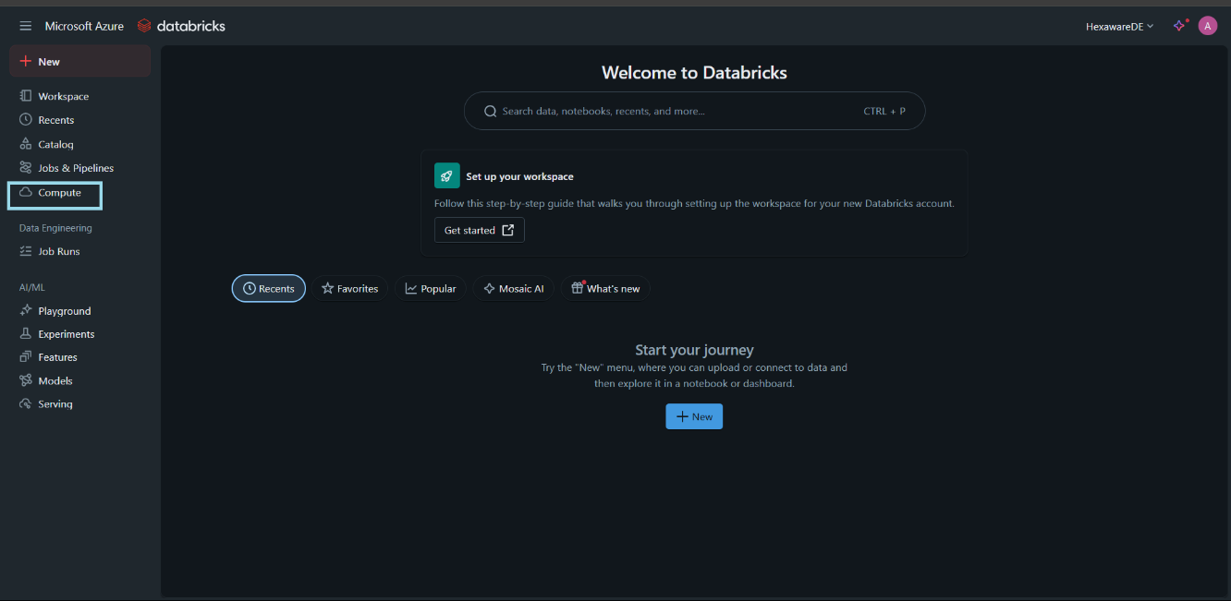

Click the Create Compute

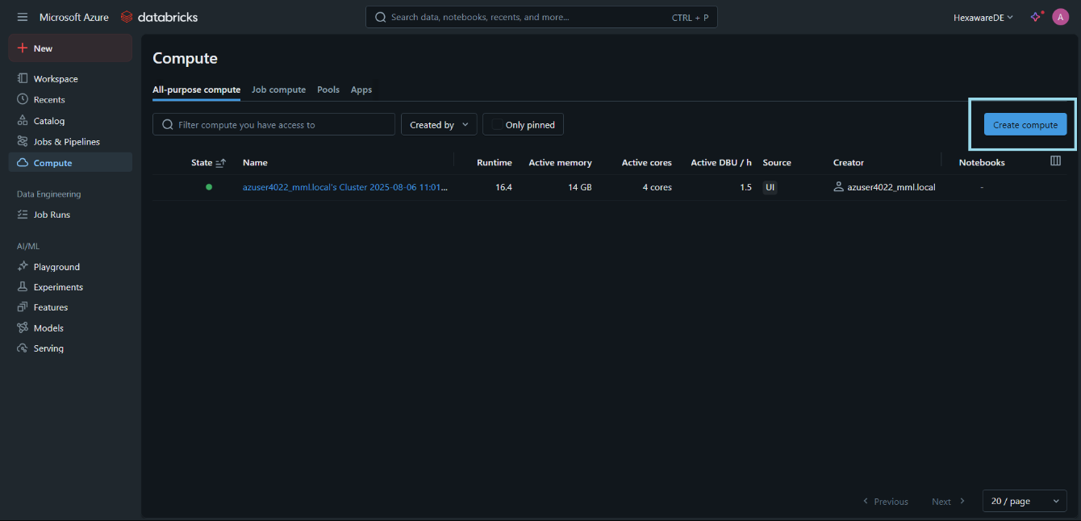

Set the configuration for the cluster and click create

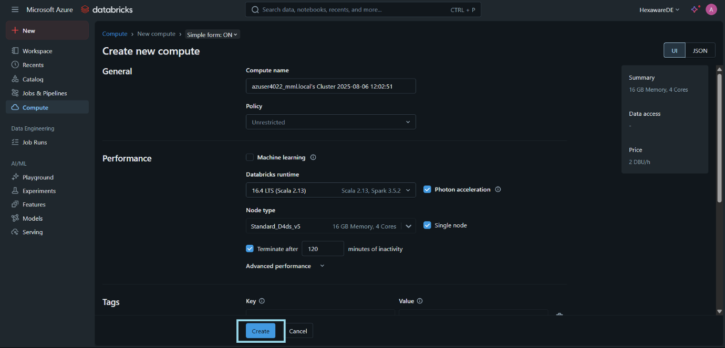

The cluster will be created successfully

